Project Design Phase
Problem – Solution Fit Template

Date | 15 February 2026
Team ID | LTVIP2026TMIDS38689
Project Name | Electric Motor Temperature Prediction using Machine Learning
Maximum Marks | 2 Marks

Problem – Solution Fit Template:
Our solution is a Machine Learning-based temperature prediction system that analyzes historical motor sensor data and predicts the motor temperature in advance. By training regression models on preprocessed datasets, the system can estimate temperature accurately and help detect potential overheating before it occurs.
Purpose:
- Solve complex industrial problems related to electric motor overheating by providing an accurate predictive temperature monitoring system.
- Succeed faster and increase solution adoption by integrating with existing sensor data collection systems without requiring major infrastructure changes.
- Sharpen communication and maintenance strategy by providing early temperature predictions and actionable alerts.
- Increase touch-points with maintenance teams by solving frequent overheating issues and reducing costly breakdowns.
- Understand the existing motor performance patterns using historical data in order to improve efficiency and reliability for industrial users.

Template:
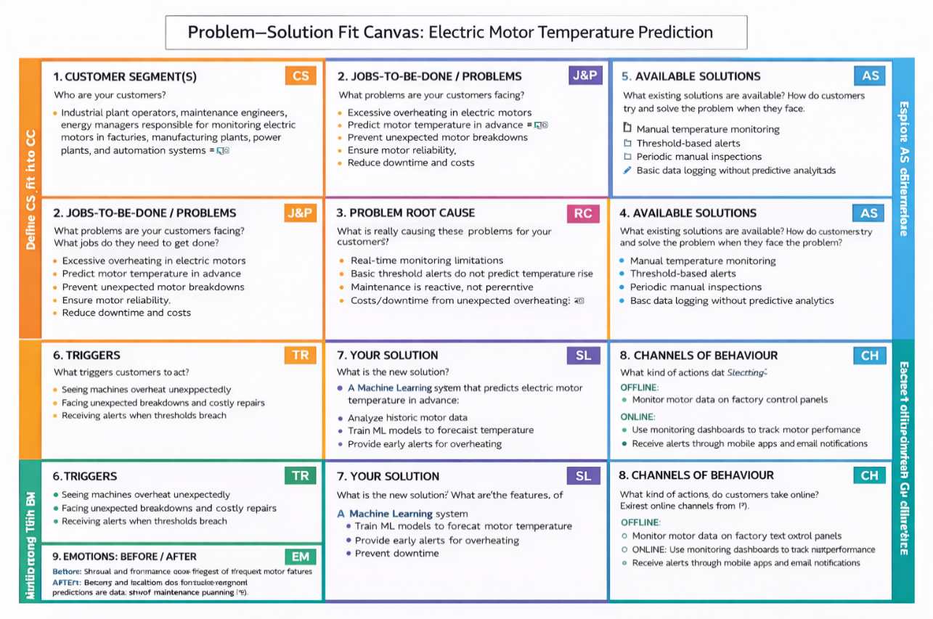
References:
- https://www.ideahackers.network/problem-solution-fit-canvas/
- https://medium.com/@epicantus/problem-solution-fit-canvas-aa3dd59cb4fe

